**Clothing Database Management System**

Shaik Masthan Vali

<https://github.com/Masthan9712/True-Style-Clothing.git>

April 15, 2022

I have created a business for selling textiles known as “True Style Clothing”.

For this business I will be creating a new database which stores all the information regarding Employees (Employee ID, Names, Job role & Salary), Customers (Customer Name, Date of Birth, Phone, Email & Address), Transactions (Transaction amount & transaction method), Costume (Costume ID, Brand, Quantity, Price & Size) and Categories (Men, Women, Kids). This data is very essential for running the store to keep track of all the orders, employees and their salary pay, offering discounts to the regular customers and maintain the stock up to date. If the stock is less, more collection needs to be ordered. Everyday transactions gives the overview of the most salable and liked costumes which helps to order those costumes more in quantity.

I have to enter the employee data at the time of their joining and it contains all details about their role and pay. Customer data is generated when they purchase any costume from the store.

As I am running this store, I should be able to view all the data to get a detailed overview of how the business is running and what needs to be taken care of. Store managers needs access to all the employee data and the costumes data. In case if any particular costume is running low in that store they can check whether it is available in the near store. Sales team needs to have access to the transactions data to check how well the costumes are getting sold. If the business is running good, sales team can make analysis to put some offers on the most salable costumes and even encourage customers to buy it.

**Week 2 - Project part 2**

For my True Style Clothing business application I will be creating 6 entities and described them below:

1. Customer Info - This entity describes the basic information of a customer like Customer First Name, Customer Last Name, Customer Email, Customer DOB, Customer Orders.
2. Employee Info - This entity describes the employee information like Employee ID, Employee First Name, Employee Last Name, Employee Role, Employee Salary, Employee Sales.
3. Costume Info - This entity describes the Costume ID, Brand, Shirts Price, Trousers Price.
4. Category info - This describes the available sizes for all categories. S - small, M - Medium and L - Large, Gender - Male and Female and Age.
5. Vendor Info - This entity describes the Vendor name, Delivery Date, Shirts Quantity, Trousers Quantity.
6. Sales Info - This entity describes the sales details like Date, Number of costumes sold, Total sale value.

Below is the chart representation for my entities:

|  |  |
| --- | --- |
| **Customer Info** | **Data type** |
| Customer First Name | varChar[30] |
| Customer Last Name | varChar[30] |
| Customer Email | varChar[30] |
| Customer DOB | date |
| Customer Orders | Integer |

|  |  |
| --- | --- |
| **Employee Info** | **Data type** |
| Employee First Name | varChar[30] |
| Employee Last Name | varChar[30] |
| Role | varChar[30] |
| Salary | Float |
| Sales Completed | Integer |

|  |  |
| --- | --- |
| **Costume Info** | **Data type** |
| Costume ID | Integer |
| Brand | varChar[20] |
| Shirts price | Float |
| Trousers price | Float |

|  |  |
| --- | --- |
| **Categories Info** | **Data type** |
| Gender | char |
| Size | char |
| Age | int |

|  |  |
| --- | --- |
| **Vendor Info** | **Data type** |
| Vendor Name | varChar[20] |
| Delivery date | date |
| Shirts Quantity | Integer |
| Trousers Quantity | Integer |

|  |  |
| --- | --- |
| **Sales Info** | **Data type** |
| Date | date |
| Costumes Sold | Integer |
| Sale value | Float |

**Week 3 - Project Part 3**

**UML diagram - UMLet**

I have used the UMLet tool for drawing the UML diagram for my business application TrueStyleClothing.

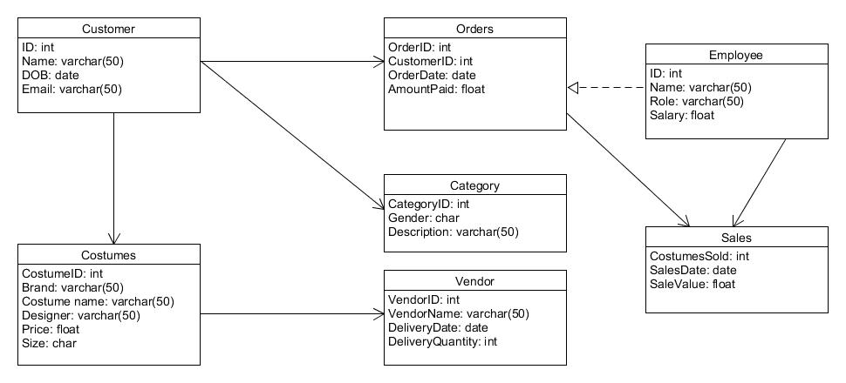

**ER Diagram - Crow’s Foot Model:**

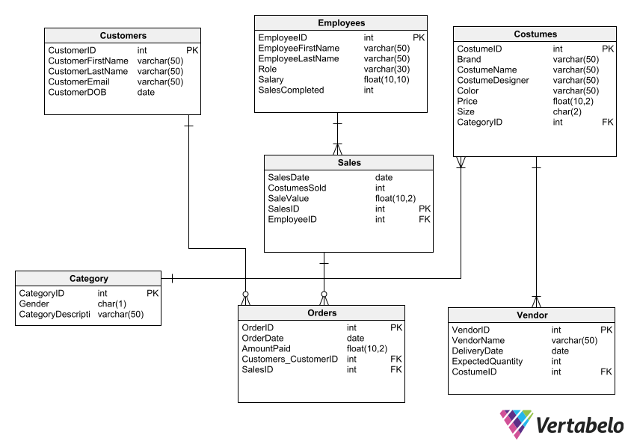

**Week 4 - Project Part 4**

In this week’s project, I am going to use the SQL query generated by Vertabelo and load the data in to tables using the csv files.

Category information is loaded into Category table using category.csv file. Fields terminated by uses the parameter “,” to represent each element, Lines terminated by uses the parameter “\r\n” to represent the end of the line, Ignore 1 lines is used to ignore the headings in the CSV file.

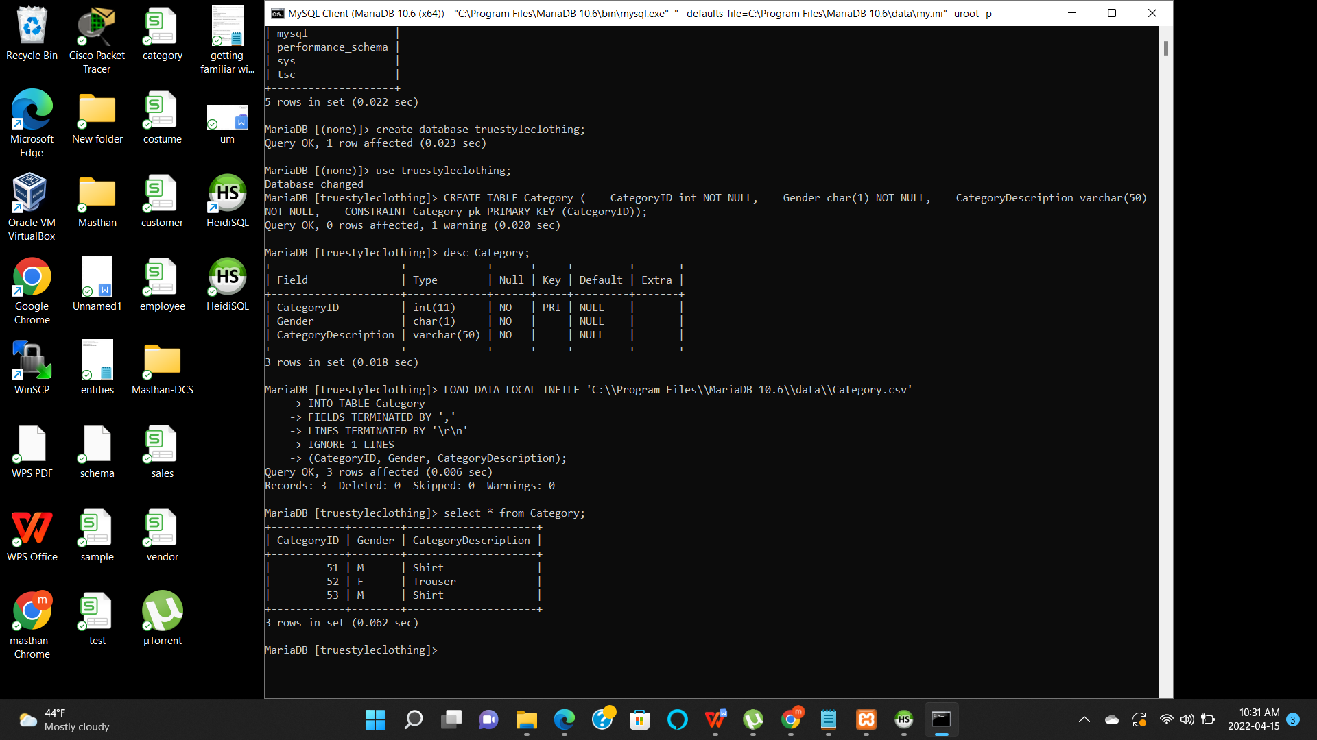

Costume information is loaded into Costumes table using costume.csv file. Fields terminated by uses the parameter “,” to represent each element, Lines terminated by using the parameter “\r\n” to represent the end of the line, Ignore 1 lines is used to ignore the headings in the CSV file.

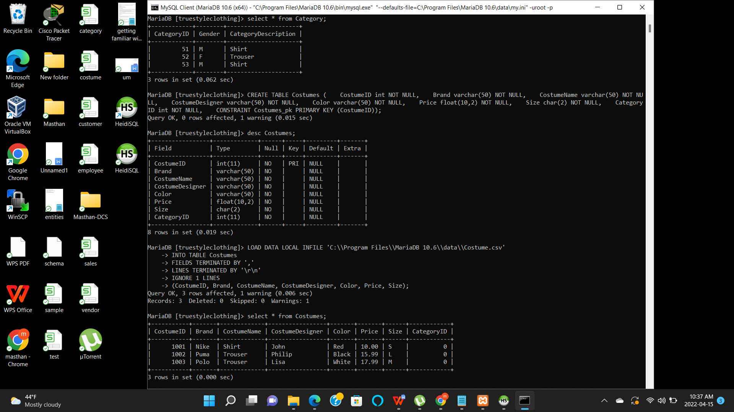

Customer information is loaded into Customers table using customer.csv file. Fields terminated by uses the parameter “,” to represent each element, Lines terminated by uses the parameter “\r\n” to represent the end of the line, Ignore 1 lines is used to ignore the headings in the CSV file.

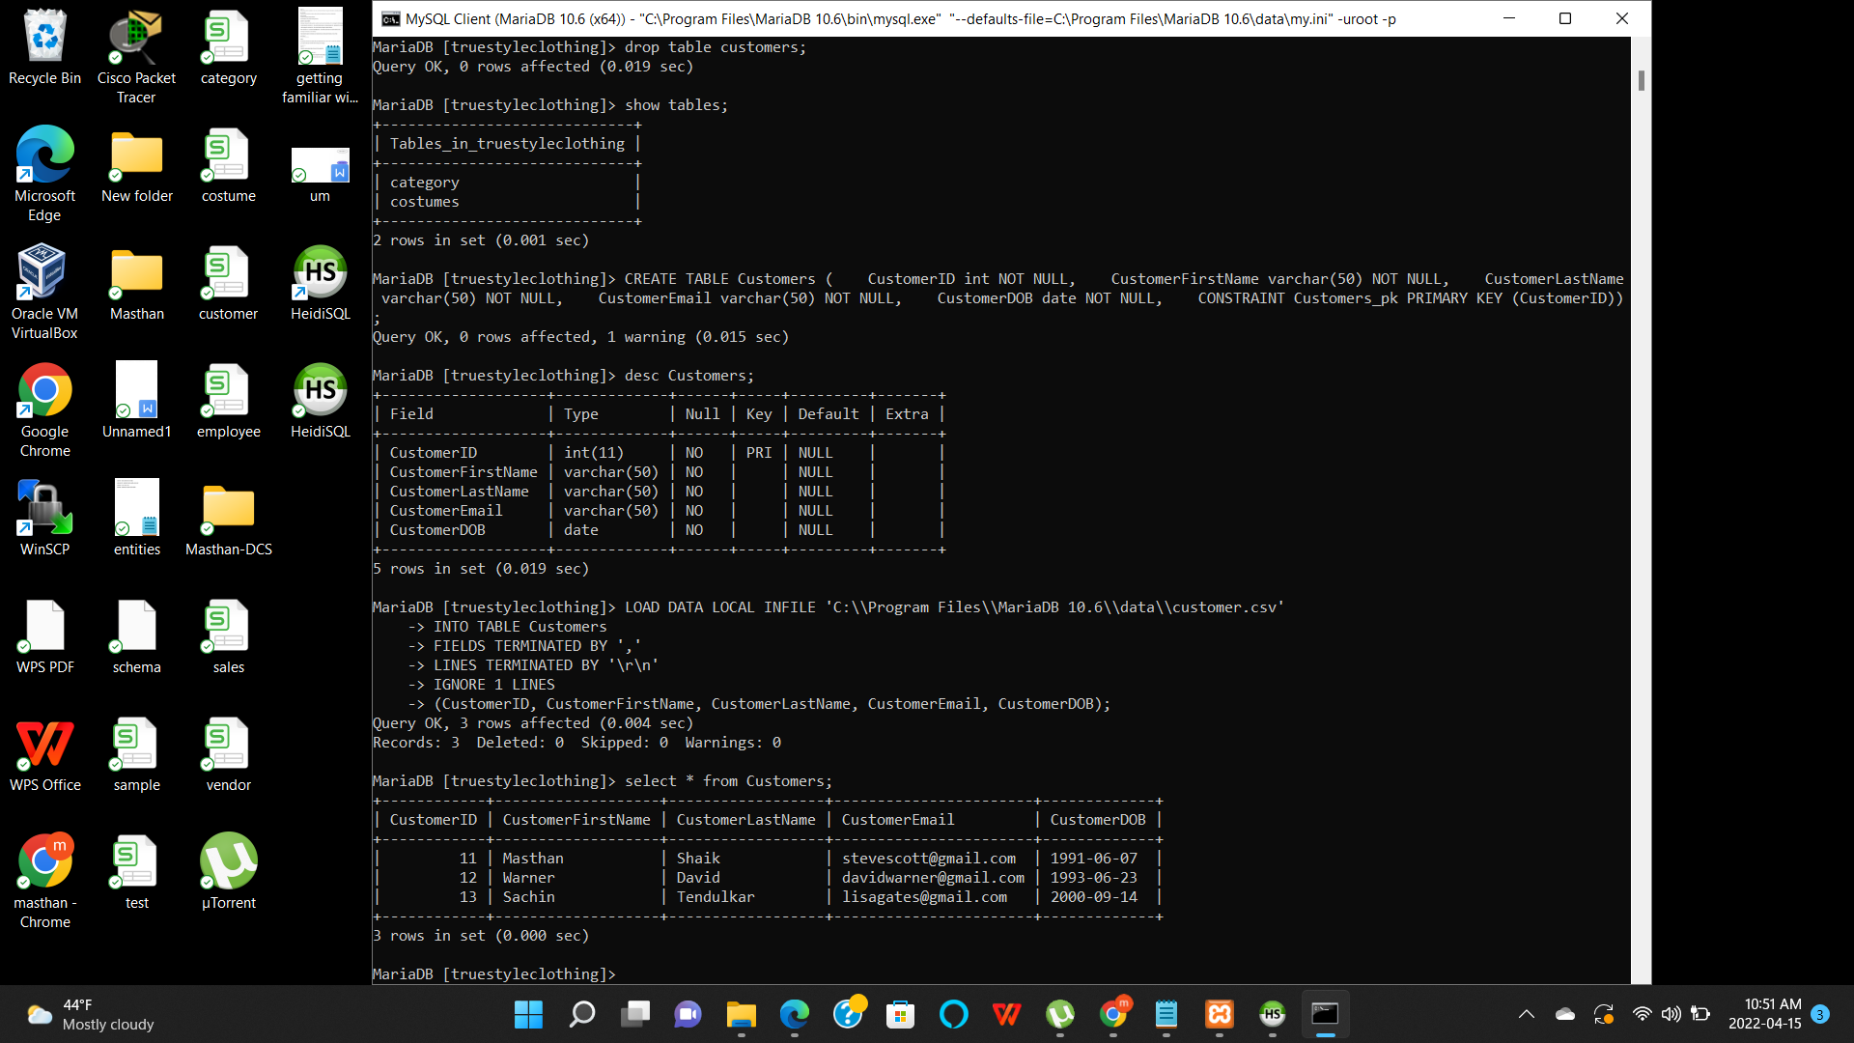

Employee information is loaded into Employees table using employee.csv file. Fields terminated by uses the parameter “,” to represent each element, Lines terminated by using the parameter “\r\n” to represent the end of the line, Ignore 1 lines is used to ignore the headings in the CSV file.

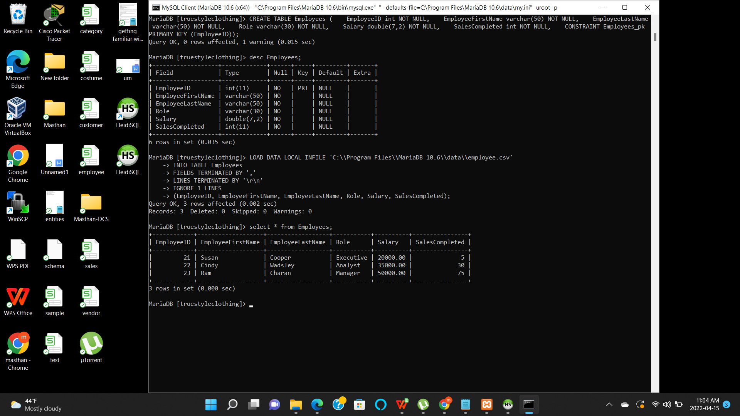

Orders information is loaded into Orders table using order.csv file. Fields terminated by uses the parameter “,” to represent each element, Lines terminated by using the parameter “\r\n” to represent the end of the line, Ignore 1 lines is used to ignore the headings in the CSV file.

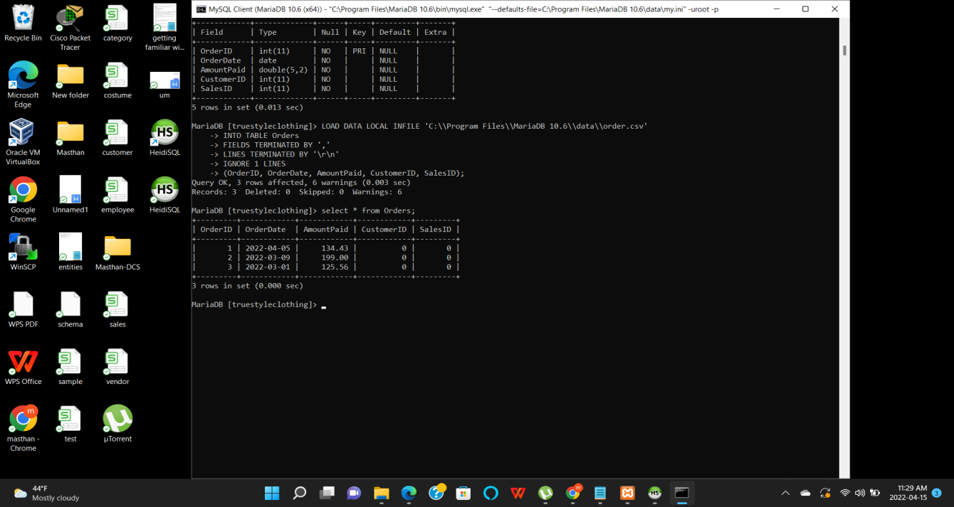

Sales information is loaded into Sales table using sale.csv file. Fields terminated by uses the parameter “,” to represent each element, Lines terminated by using the parameter “\r\n” to represent the end of the line, Ignore 1 lines is used to ignore the headings in the CSV file.

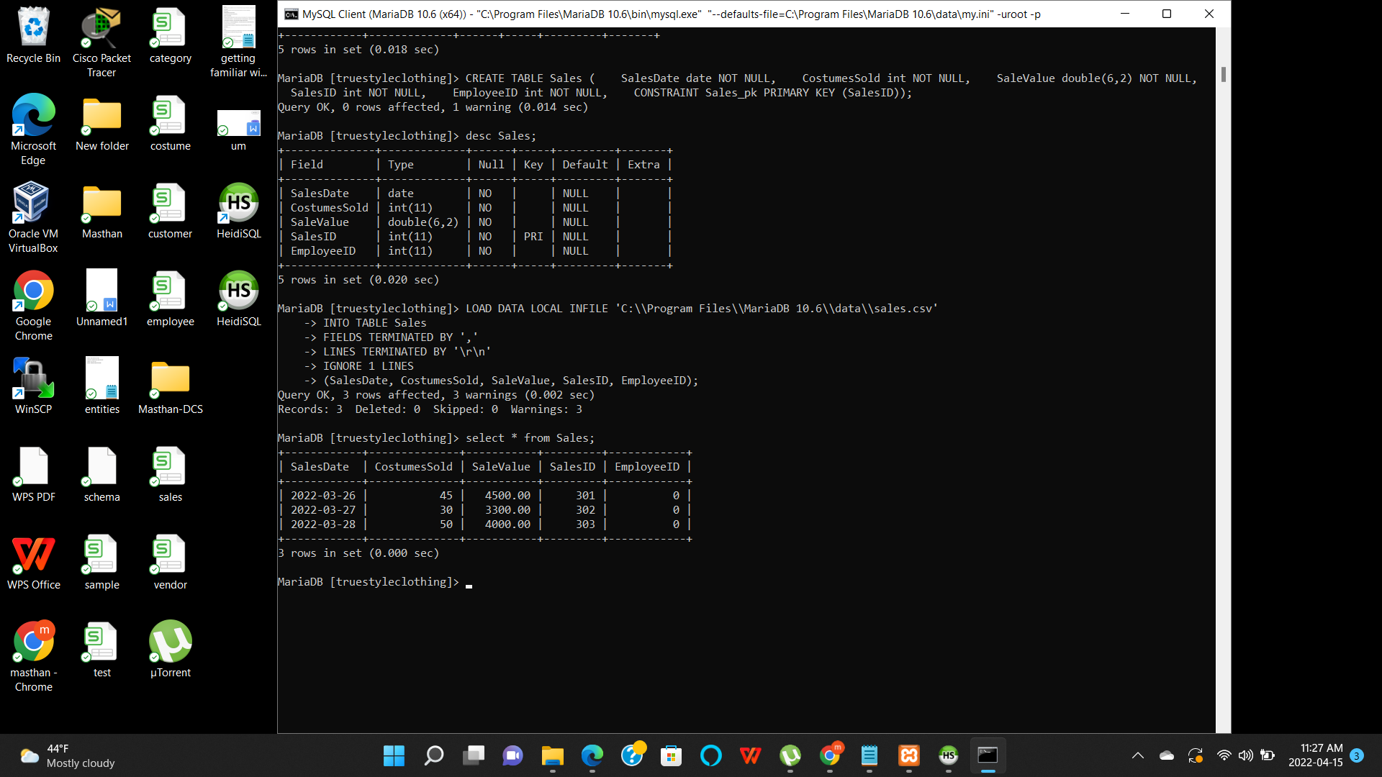

Vendor information is loaded into Vendor table using vendor.csv file. Fields terminated by uses the parameter “,” to represent each element, Lines terminated by using the parameter “\r\n” to represent the end of the line, Ignore 1 lines is used to ignore the headings in the CSV file.

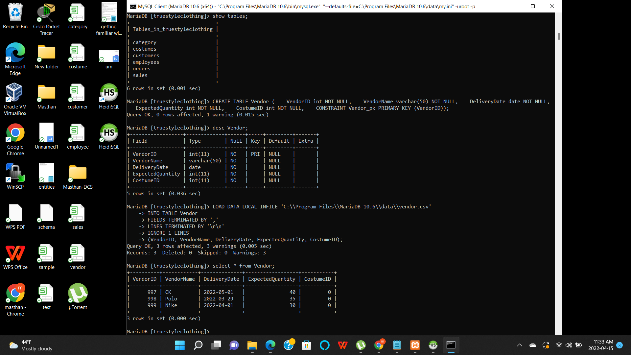

**DML Commands:**

**Insert commands:**

In the first insert query, a new record has been added to the Employees table.

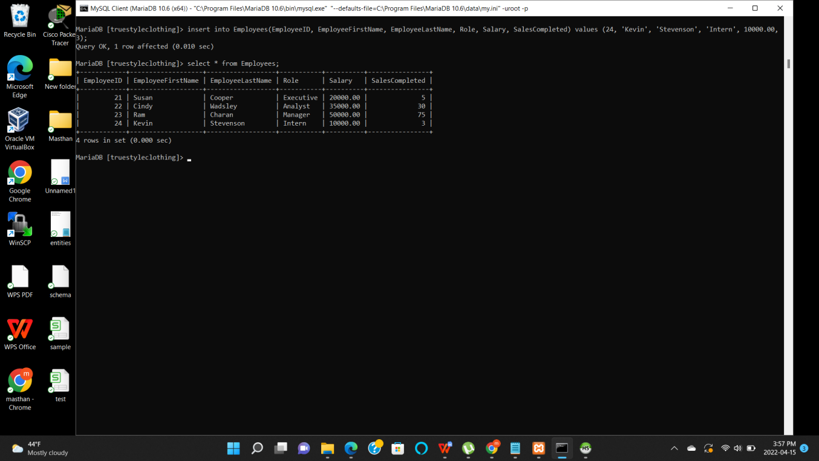

In the second insert query, a new record has been inserted into Customers table.

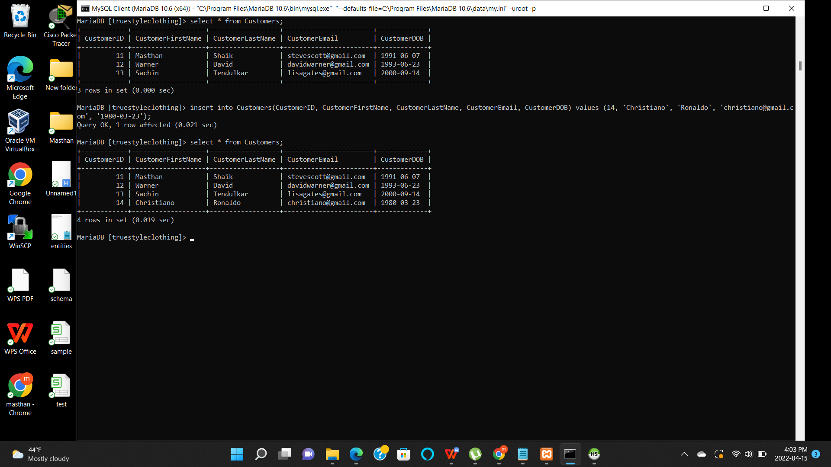

**Update commands:**

In the first update command, email address for Customer ID has changed from [stevescott@gmail.com](mailto:stevescott@gmail.com) to masthanvalishaik@yahoo.com.

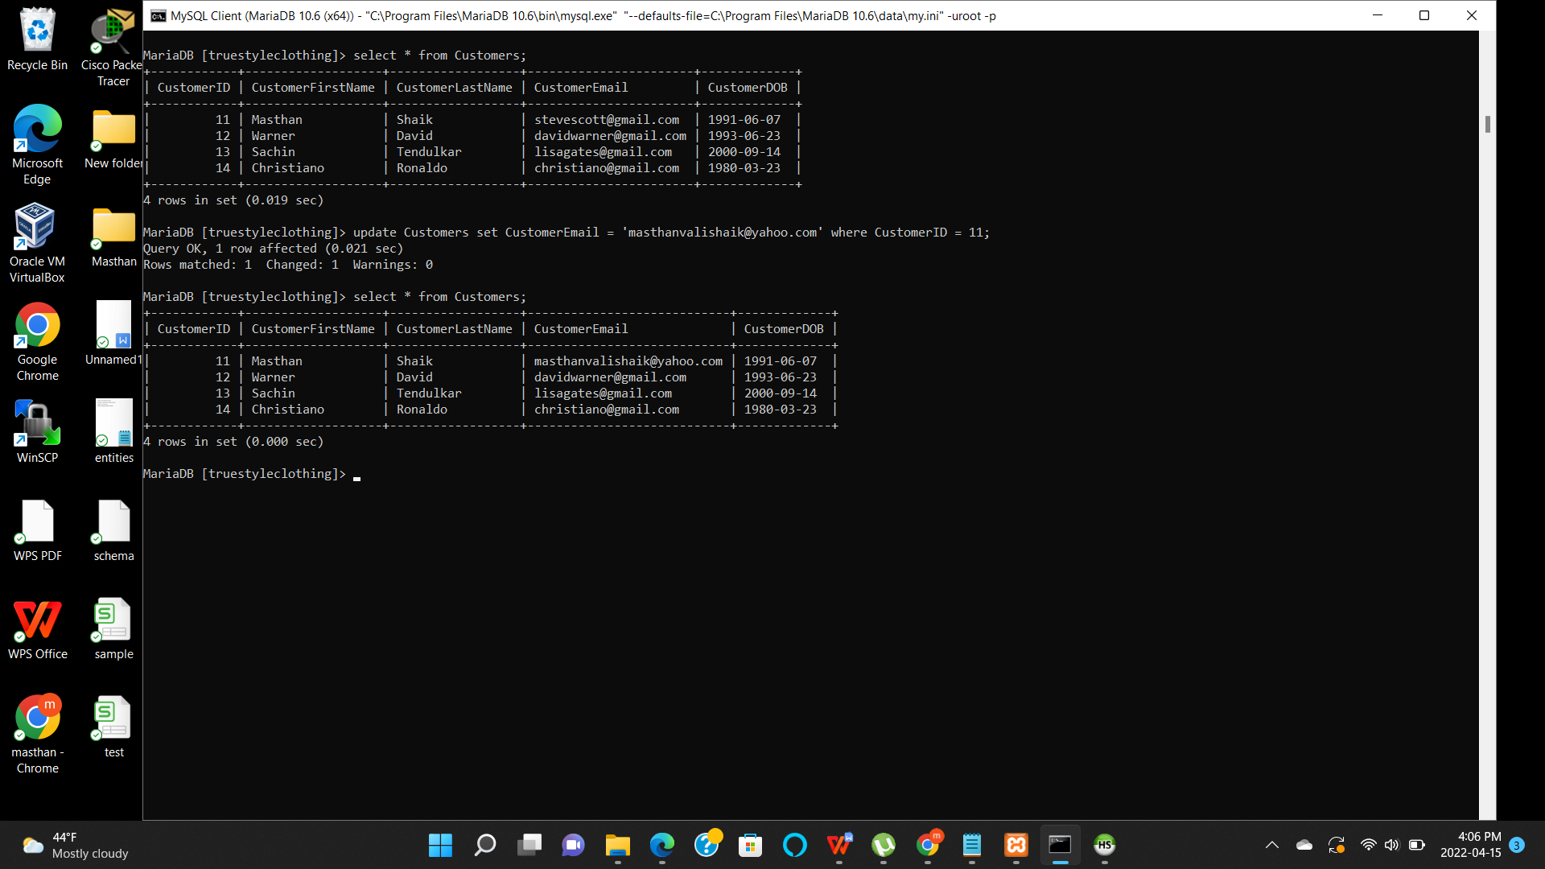

In the second update command, CostumeDesigner is changed to Malhotra and color is change to Orange from Black.

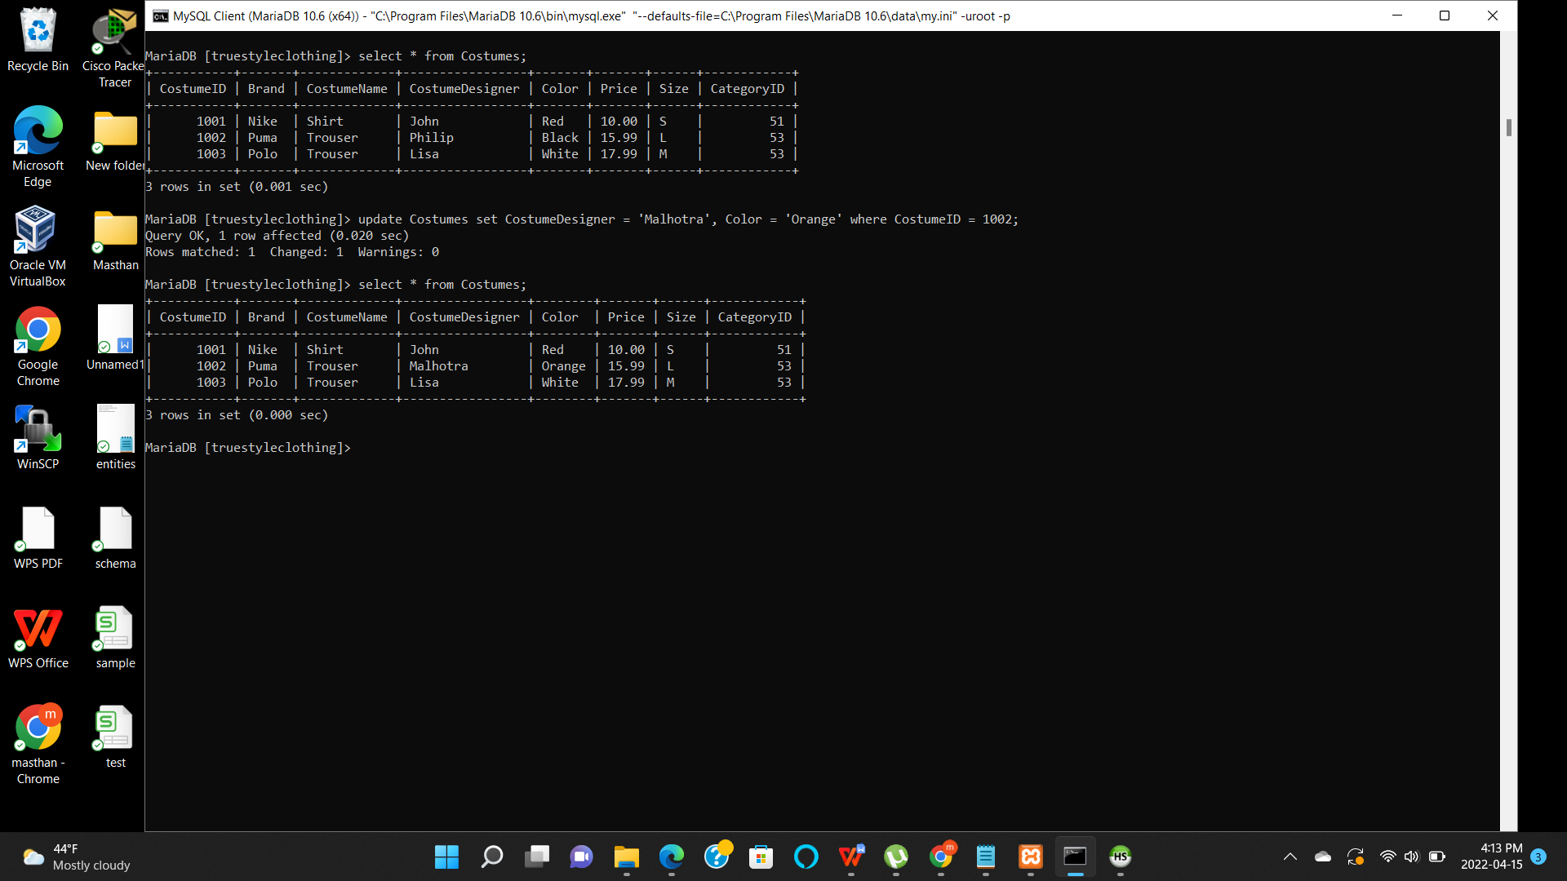

**Delete Command:**

Using delete command, a record has been removed from the Customers table with CustomerID = 14.

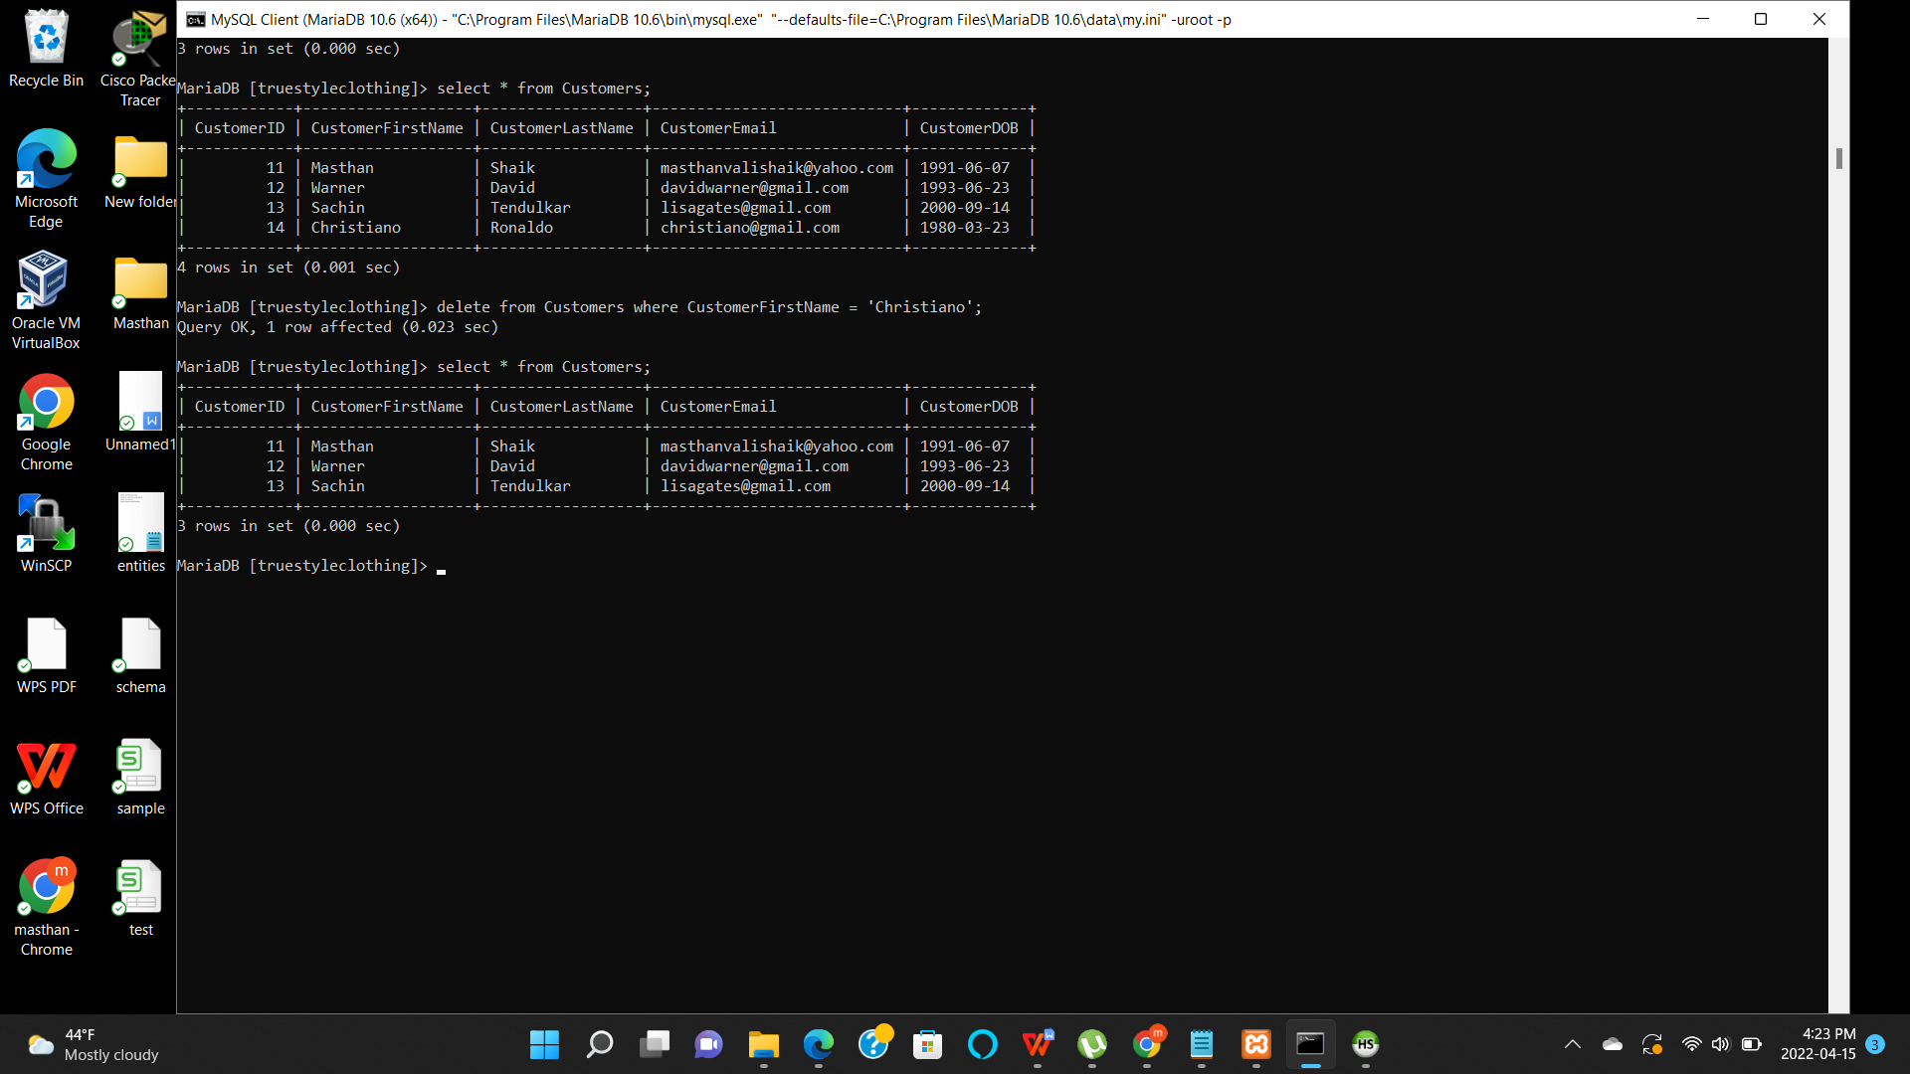

**Select Command:**

Using the simple select command, only the Brand column is selected from Costumes table.

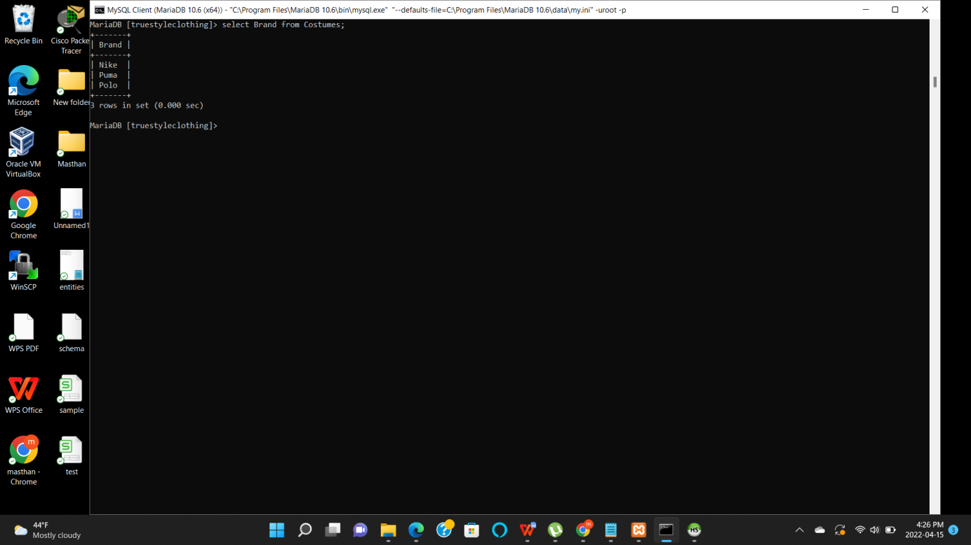

**Join Commands:**

Using the inner join, two tables Employees and Sales are joined which shows the selected columns from both tables.

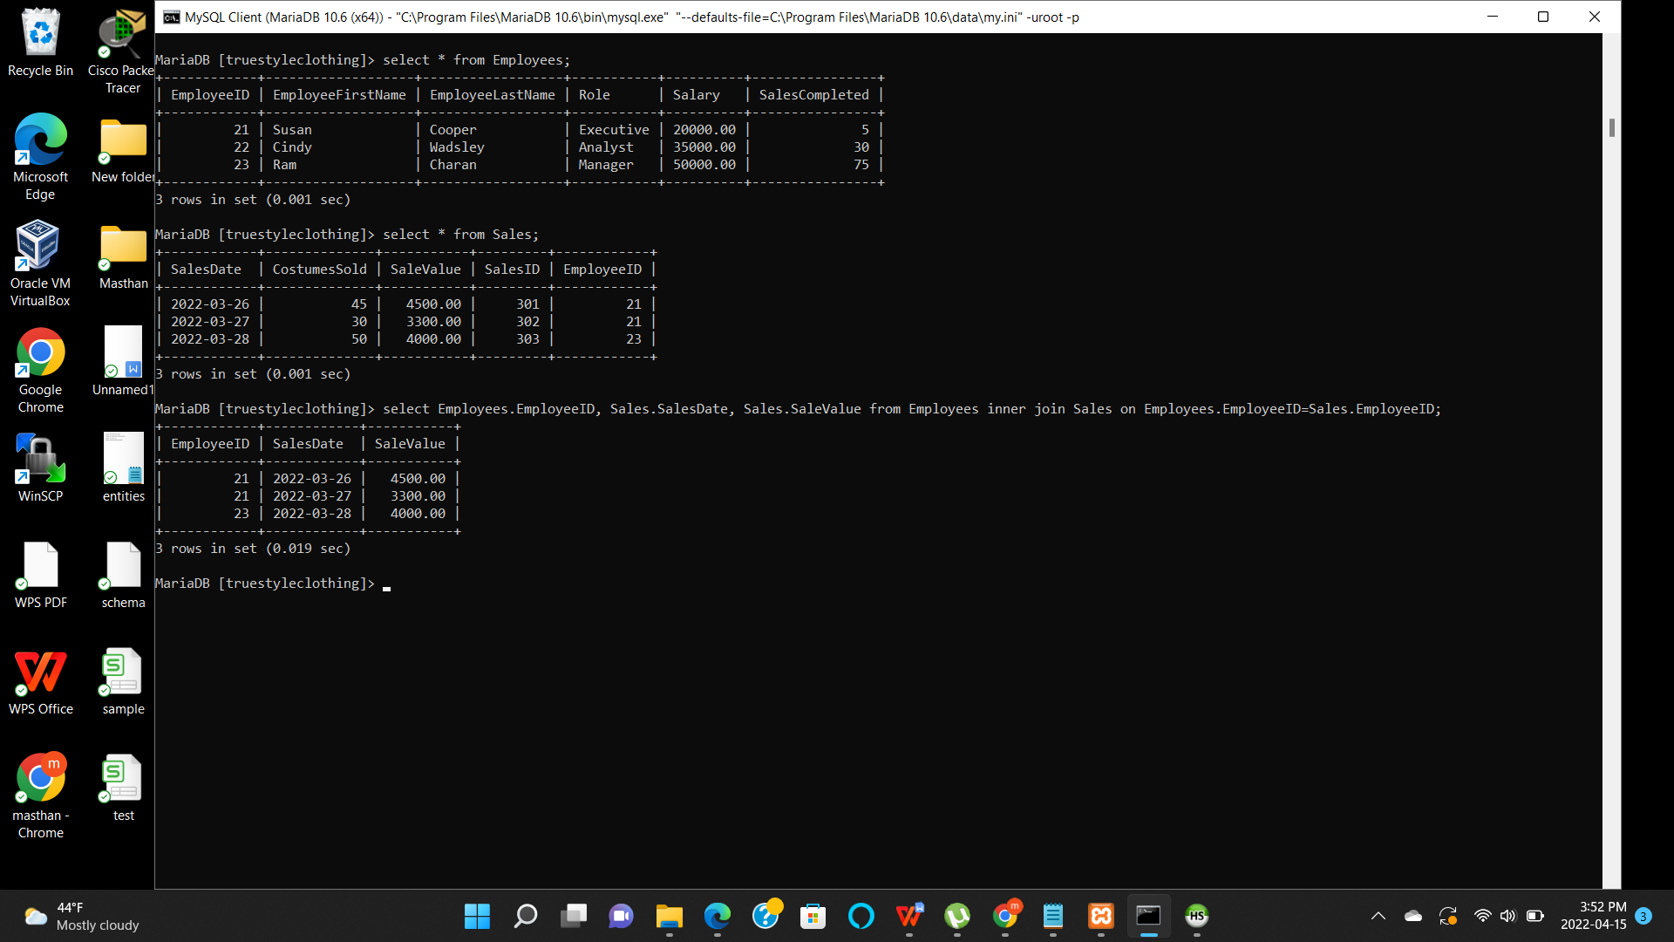

Using the right join, two tables Category and Costumes are joined. Right join shows all the records from the right table (Costumes)and the common records from the left table (Category).

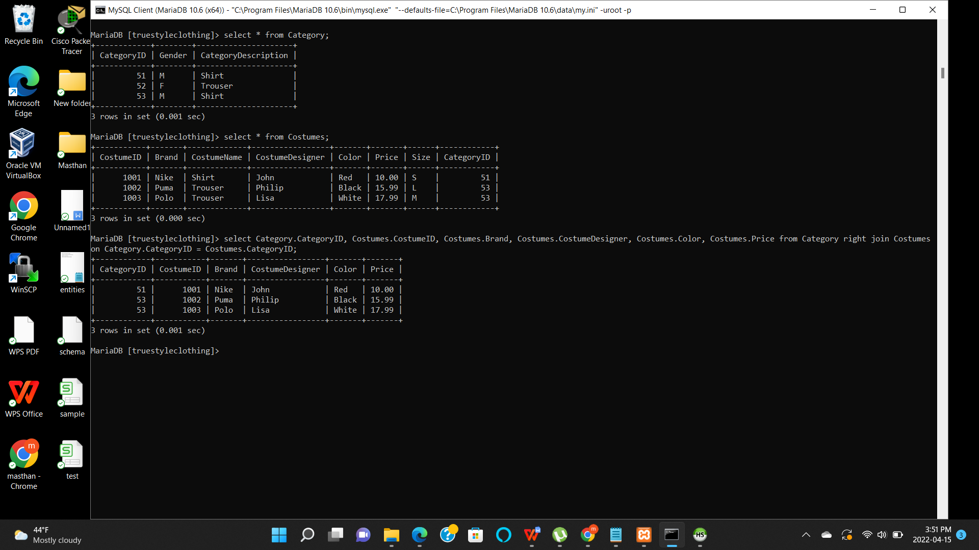

**Summary Commands:**

**Max** - Using the max command, the maximum value in a table can be identified.

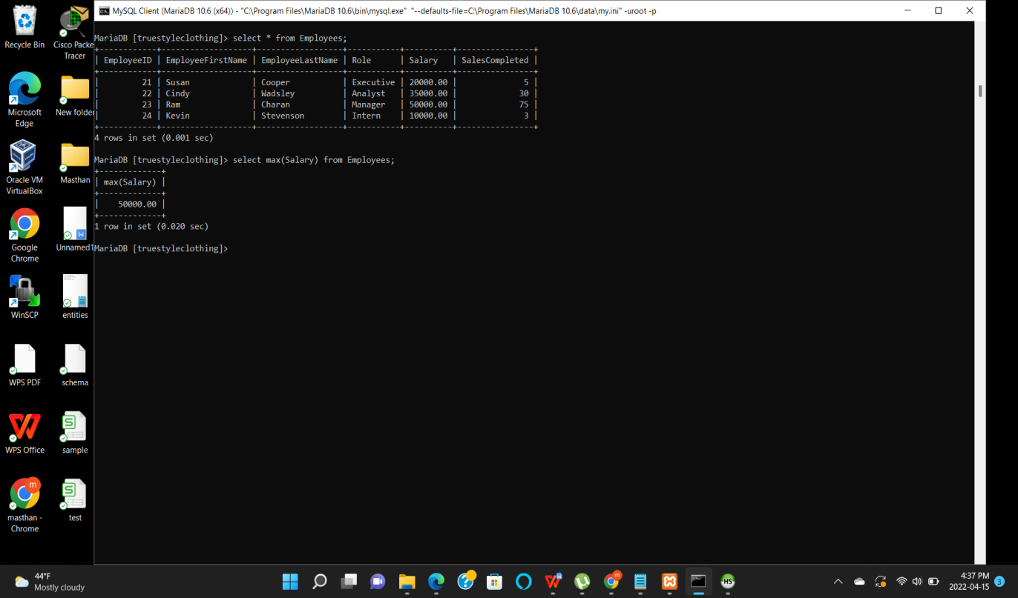

**Avg** - Using the avg command, the average of the values can be taken from any table.

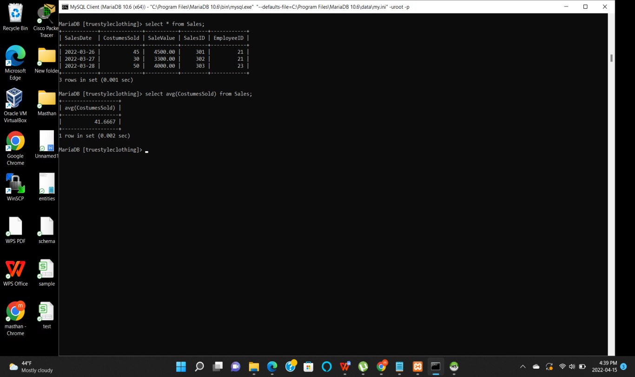

**Sum** - By using sum command, total value of any particular column can be generated.

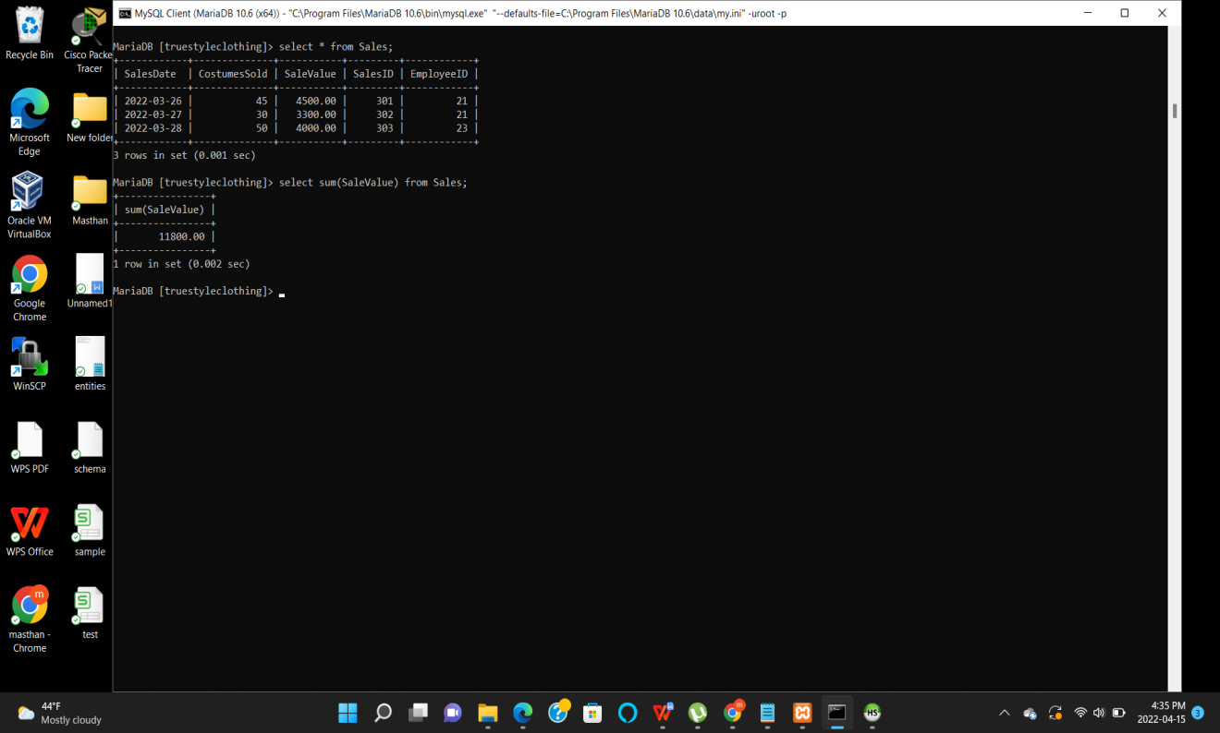

**Multi table query:**

Category and Costumes tables were used in this example to generate multi table query.

